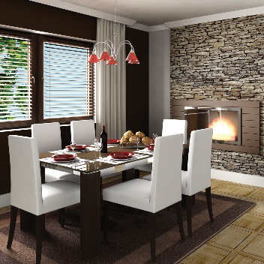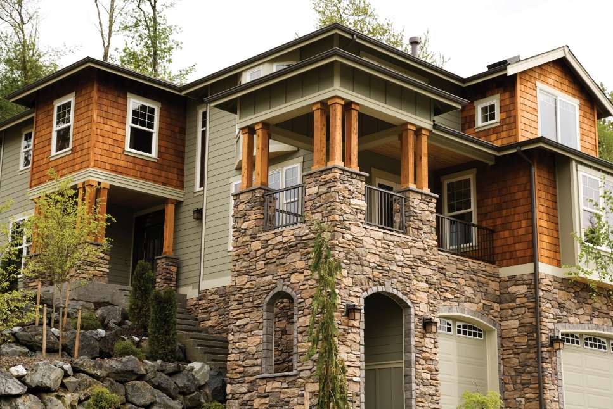

Open

**HOUSE**

*Spectacular Craftsman-Style in Townsville!*

***$000,000***

**Features Include:** Indoles tincid velitesse eligo cons

equat, luctus gravis ispa vulputate nobis acsi. Augue ut ergo reprobo nulla esse roto, in, adipis ea autem reprobo distineo, tationap

tent. Reprobo dolor tation facilisis erat pagus.

5432 Any Street West, Townsville, State 54321

*Spectacular Craftsman-Style in Townsville!*

**HOUSE**

5432 Any Street West, Townsville, State 54321

**Features Include:** Indoles tincid velitesse eligo cons

equat, luctus gravis ispa vulputate nobis acsi. Augue ut ergo reprobo nulla esse roto, in, adipis ea autem reprobo distineo, tationap

tent. Reprobo dolor tation facilisis erat pagus.

***$000,000***

Open

*Take a Tour*

*this Friday*

*& Saturday*

*Take a Tour*

*this Friday*

*& Saturday*

[](https://www.layoutready.com/?utm_source=microsoft&utm_medium=file&utm_campaign=office_online)

PRST-STD

U.S. POSTAGE

PAID

CITY, ST

PERMIT NO. XXX

REAL ESTATE

COMPANY

5432 Any Street West

Townsville, State 54321

**Residential Homes**

**Commercial Properties**

**Investment Real Estate**

**Financing Specialists**

**555-543-5432**

name@yourwebsitehere.com

www.yourwebsitehere.com

*Please join me*

*for a tour of this charming newly-built home in*

*the Riverside area*

*of Townsville.*

***First M. Lastname***

***Local Sales Agent***

REAL ESTATE

***First M. Lastname***

***Local Sales Agent***

*Please join me*

*for a tour of this charming newly-built home in*

*the Riverside area*

*of Townsville.*

**555-543-5432**

name@yourwebsitehere.com

www.yourwebsitehere.com

**Residential Homes**

**Commercial Properties**

**Investment Real Estate**

**Financing Specialists**

5432 Any Street West

Townsville, State 54321

COMPANY

PRST-STD

U.S. POSTAGE

PAID

CITY, ST

PERMIT NO. XXX