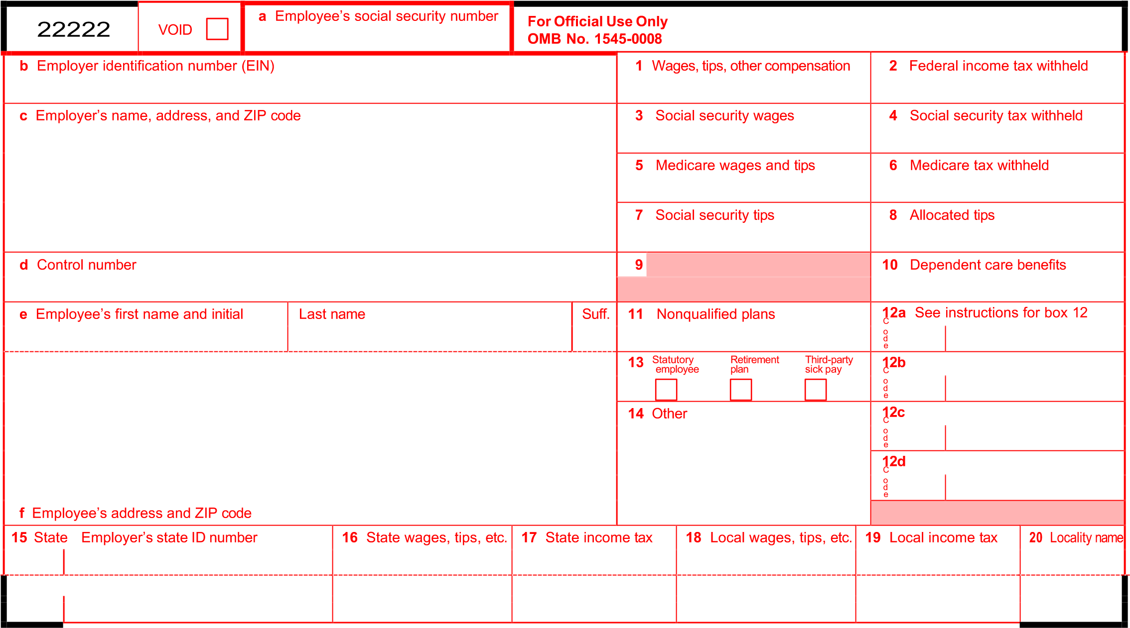 **Form W-2 Wage and Tax Statement** 2024 Department**For** of **Privacy** the Treasury **Act and**—Internal **Paperwork** Revenue **Reduction** Service

**Copy A—For Social Security Administration.** Send this entire page with **Act Notice, see the separate instructions.**

Form W-3 to the Social Security Administration; photocopies are **not** acceptable. Cat. No. 10134D

**Do Not Cut, Fold, or Staple Forms on This Page**

|  |  |  |  |  |  |  |  |  |  |  |  |  |  |  |  |  |
| --- | --- | --- | --- | --- | --- | --- | --- | --- | --- | --- | --- | --- | --- | --- | --- | --- |
| 22222 | | **a** Employee’s social security number | | OMB No. 1545-0008 | | | | | | | | | | | | |
| **b** Employer identification number (EIN) | | | | | **1** Wages, tips, other compensation | | | | | | | | | **2** Federal income tax withheld | | |
| **c** Employer’s name, address, and ZIP code | | | | | **3** Social security wages | | | | | | | | | **4** Social security tax withheld | | |
| **5** Medicare wages and tips | | | | | | | | | **6** Medicare tax withheld | | |
| **7** Social security tips | | | | | | | | | **8** Allocated tips | | |
| **d** Control number | | | | | **9** |  | | | | | | | | **10** Dependent care benefits | | |
|  | | | | | | | | |
| 1. Employee’s first name and initial Last name Suff.                        1. Employee’s address and ZIP code | | | | | **11** Nonqualified plans | | | | | | | | | **12**C **a**  o d e |  | |
| **13** Statutoryemployee Retirementplan Thirdsick pay-party | | | | | | | | | **12**C **b**  o d e |  | |
|  | |  |  |  |  |  |  | |
| **14** Other | | | | | | | | | **12**C **c**  o d e |  | |
| **12**C **d**  o d e |  | |
|  | | |
| **15** State | Employer’s state ID number | | **16** State wages, tips, etc. | **17** State income tax | | | | **18** Local wages, tips, etc. | | | | | **19** Local income tax | | | **20** Locality name |
|  |  | |  |  | | | |  | | | | |  | | |  |

**W-2 Wage and Tax Statement** 2024 Department of the Treasury—Internal Revenue Service

**Form**

# Copy 1—For State, City, or Local Tax Department

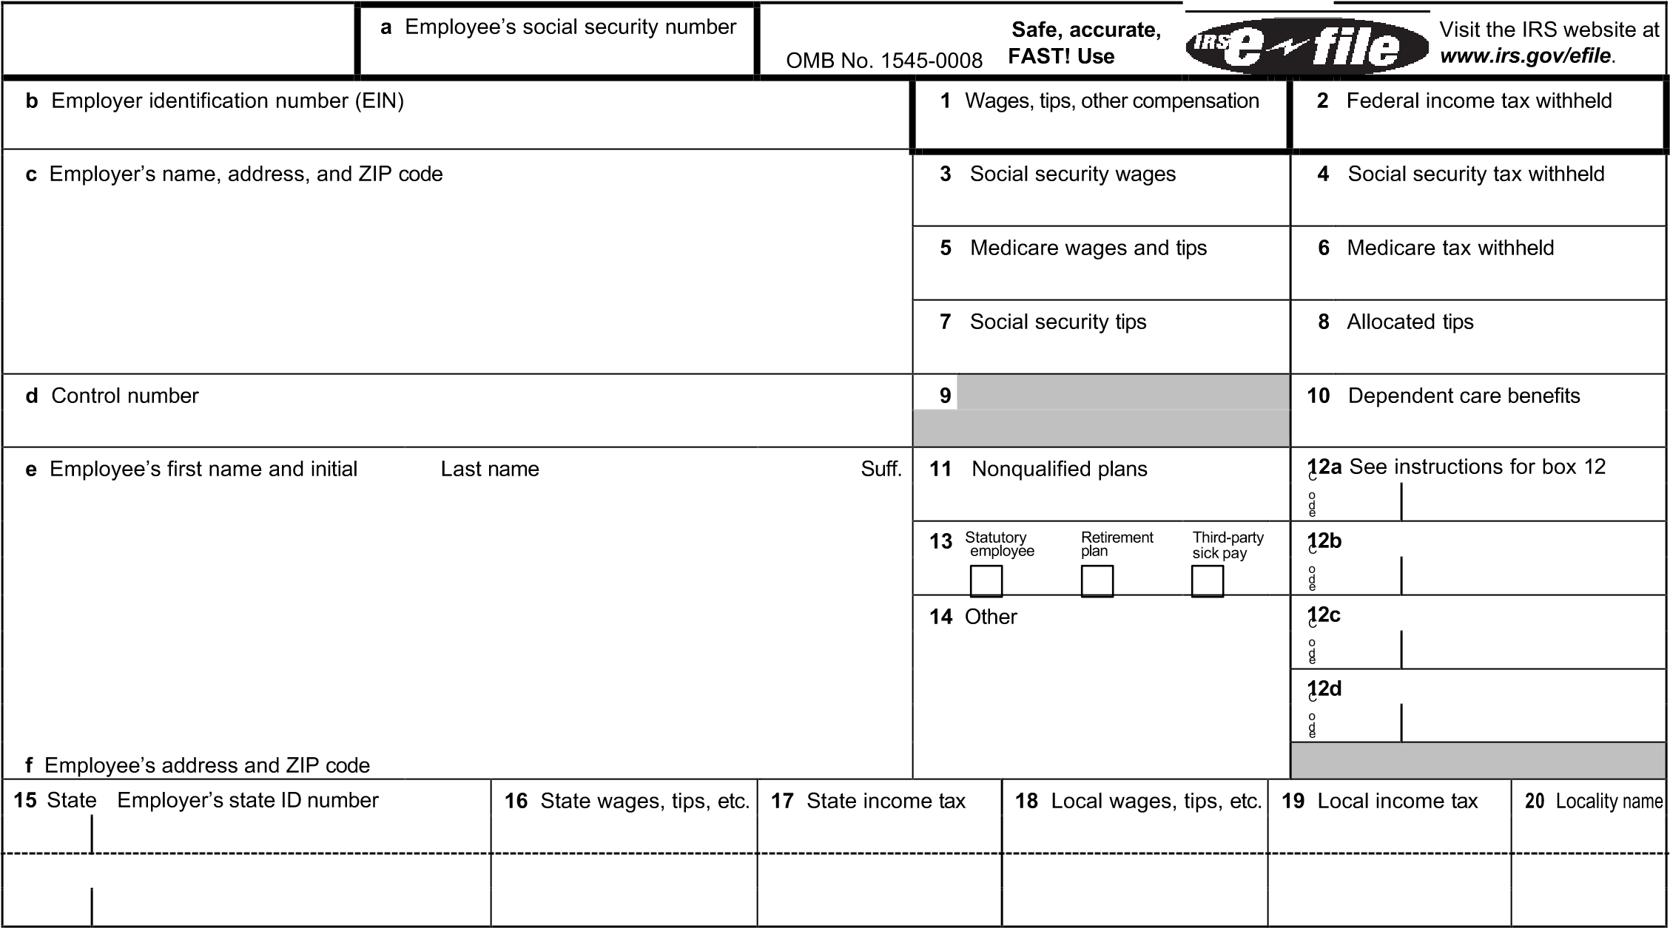

**Form W-2 Wage and Tax Statement**  of the Treasury—Internal Revenue Service

**Copy B—To Be Filed With Employee’s FEDERAL Tax Return.**

This information is being furnished to the Internal Revenue Service.

**Future developments.** For the latest information about developments related to Form W-2, such as legislation enacted after it was published, go to *www.irs.gov/FormW2*.

# Notice to Employee

**Do you have to file?** Refer to the Form 1040 instructions to determine if you are required to file a tax return. Even if you don’t have to file a tax return, you may be eligible for a refund if box 2 shows an amount or if you are eligible for any credit.

**Earned income tax credit (EITC).** You may be able to take the EITC for 2024 if your adjusted gross income (AGI) is less than a certain amount. The amount of the credit is based on income and family size. Workers without children could qualify for a smaller credit. You and any qualifying children must have valid social security numbers (SSNs). You can’t take the EITC if your investment income is more than the specified amount for 2024 or if income is earned for services provided while you were an inmate at a penal institution. For 2024 income limits and more information, visit *www.irs.gov/EITC*. See also Pub. 596. **Any EITC that is more than your tax liability is refunded to you, but only if you file a tax return.**

**Employee’s social security number (SSN).** For your protection, this form may show only the last four digits of your

SSN. However, your employer has reported your complete SSN to the IRS and the Social Security Administration (SSA).

**Clergy and religious workers.** If you aren’t subject to social security and Medicare taxes, see Pub. 517.

**Corrections.** If your name, SSN, or address is incorrect, correct Copies B, C, and 2 and ask your employer to correct your employment record. Be sure to ask the employer to file Form W-2c, Corrected Wage and Tax Statement, with the SSA to correct any name, SSN, or money amount error reported to the SSA on Form W-2. Be sure to get your copies of Form W-2c from your employer for all corrections made so you may file them with your tax return. If your name and SSN are correct but aren’t the same as shown on your social security card, you should ask for a new card that displays your correct name at any SSA office or by calling 800-772-1213. You may also visit the SSA website at *www.SSA.gov.*

**Cost of employer-sponsored health coverage (if such cost is provided by the employer).** The reporting in box 12, using code DD, of the cost of employer-sponsored health coverage is for your information only. **The amount reported with code DD is not taxable.**

**Credit for excess taxes.** If you had more than one employer in 2024 and more than $10,453.20 in social security and/or Tier 1 railroad retirement (RRTA) taxes were withheld, you may be able to claim a credit for the excess against your federal income tax. See the Form 1040 instructions. If you had more than one railroad employer and more than $6,129.90 in Tier 2 RRTA tax was withheld, you may be able to claim a refund on Form 843. See the Instructions for Form 843.

(See also *Instructions for Employee* on the back of Copy C.)

|  |  |  |  |  |  |  |  |  |  |  |  |  |  |  |  |  |  |  |  |  |  |  |  |  |  |  |  |  |  |  |  |  |  |  |  |  |  |  |  |  |  |  |  |  |  |  |  |  |  |  |  |  |  |  |  |  |  |  |  |  |  |  |  |  |  |  |  |  |  |  |  |  |  |  |  |  |  |  |  |  |  |  |  |  |  |  |  |  |  |  |  |  |  |  |  |  |  |  |  |  |  |  |  |  |  |  |  |  |  |  |  |  |  |  |  |  |  |  |  |  |  |  |  |  |  |  |  |  |  |  |  |  |  |  |  |  |  |  |  |  |  |  |  |  |  |  |  |  |  |  |  |  |  |  |  |  |  |  |  |  |  |  |  |  |  |  |  |  |  |  |  |  |  |  |  |  |  |  |  |  |  |  |  |  |  |  |  |  |  |  |  |
| --- | --- | --- | --- | --- | --- | --- | --- | --- | --- | --- | --- | --- | --- | --- | --- | --- | --- | --- | --- | --- | --- | --- | --- | --- | --- | --- | --- | --- | --- | --- | --- | --- | --- | --- | --- | --- | --- | --- | --- | --- | --- | --- | --- | --- | --- | --- | --- | --- | --- | --- | --- | --- | --- | --- | --- | --- | --- | --- | --- | --- | --- | --- | --- | --- | --- | --- | --- | --- | --- | --- | --- | --- | --- | --- | --- | --- | --- | --- | --- | --- | --- | --- | --- | --- | --- | --- | --- | --- | --- | --- | --- | --- | --- | --- | --- | --- | --- | --- | --- | --- | --- | --- | --- | --- | --- | --- | --- | --- | --- | --- | --- | --- | --- | --- | --- | --- | --- | --- | --- | --- | --- | --- | --- | --- | --- | --- | --- | --- | --- | --- | --- | --- | --- | --- | --- | --- | --- | --- | --- | --- | --- | --- | --- | --- | --- | --- | --- | --- | --- | --- | --- | --- | --- | --- | --- | --- | --- | --- | --- | --- | --- | --- | --- | --- | --- | --- | --- | --- | --- | --- | --- | --- | --- | --- | --- | --- | --- | --- | --- | --- | --- | --- | --- | --- | --- | --- | --- | --- | --- | --- | --- |
| |  |  |  |  |  |  |  |  |  |  |  |  |  |  |  |  |  | | --- | --- | --- | --- | --- | --- | --- | --- | --- | --- | --- | --- | --- | --- | --- | --- | --- | |  | | **a** Employee’s social security number | | This information is being furnished to the Internal Revenue Service. If you are required to file a tax return, a negligence penalty or other sanction OMB No. 1545-0008 may be imposed on you if this income is taxable and you fail to report it. | | | | | | | | | | | | | | **b** Employer identification number (EIN) | | | | | **1** Wages, tips, other compensation | | | | | | | | | **2** Federal income tax withheld | | | | **c** Employer’s name, address, and ZIP code | | | | | **3** Social security wages | | | | | | | | | **4** Social security tax withheld | | | | **5** Medicare wages and tips | | | | | | | | | **6** Medicare tax withheld | | | | **7** Social security tips | | | | | | | | | **8** Allocated tips | | | | **d** Control number | | | | | **9** |  | | | | | | | | **10** Dependent care benefits | | | |  | | | | | | | | | | 1. Employee’s first name and initial Last name Suff.                        1. Employee’s address and ZIP code | | | | | **11** Nonqualified plans | | | | | | | | | **12**C **a** See  o d e | instructions for box 12 | | | **13** Statutoryemployee Retirementplan Thirdsick pay-party | | | | | | | | | **12b**  C o d e |  | | |  | |  |  |  |  |  |  | | | **14** Other | | | | | | | | | **12**C **c**  o d e |  | | | **12**C **d**  o d e |  | | |  | | | | **15** State | Employer’s state ID number | | **16** State wages, tips, etc. | **17** State income tax | | | | **18** Local wages, tips, etc. | | | | | **19** Local income tax | | | **20** Locality name | |  |  | |  |  | | | |  | | | | |  | | |  | |

**W-2** **Wage and Tax Statement**

**Form**

## Copy C—For EMPLOYEE’S RECORDS

(See *Notice to Employee* on the back of Copy B.)

of the Treasury—Internal Revenue Service

**Safe, accurate,**

**FAST! Use**

# Instructions for Employee

(See also *Notice to Employee* on the back of Copy B.) **Box 1.** Enter this amount on the wages line of your tax return.

**Box 2.** Enter this amount on the federal income tax withheld line of your tax return.

**Box 5.** You may be required to report this amount on Form 8959. See the Form 1040 instructions to determine if you are required to complete Form 8959.

**Box 6.** This amount includes the 1.45% Medicare tax withheld on all

Medicare wages and tips shown in box 5, as well as the 0.9% Additional Medicare Tax on any of those Medicare wages and tips above $200,000.

**Box 8.** This amount is **not** included in box 1, 3, 5, or 7. For information on how to report tips on your tax return, see the Form 1040 instructions. You must file Form 4137 with your income tax return to report at least the allocated tip amount unless you can prove with adequate records that you received a smaller amount. If you have records that show the actual amount of tips you received, report that amount even if it is more or less than the allocated tips. Use Form 4137 to figure the social security and Medicare tax owed on tips you didn’t report to your employer. Enter this amount on the wages line of your tax return. By filing Form 4137, your social security tips will be credited to your social security record (used to figure your benefits).

**Box 10.** This amount includes the total dependent care benefits that your employer paid to you or incurred on your behalf (including amounts from a section 125 (cafeteria) plan). Any amount over your employer’s plan limit is also included in box 1. See Form 2441.

**Box 11.** This amount is (a) reported in box 1 if it is a distribution made to you from a nonqualified deferred compensation or nongovernmental section 457(b) plan, or (b) included in box 3 and/or box 5 if it is a prior year deferral under a nonqualified or section 457(b) plan that became taxable for social security and Medicare taxes this year because there is no longer a substantial risk of forfeiture of your right to the deferred amount. This box shouldn’t be used if you had a deferral and a distribution in the same calendar year. If you made a deferral and received a distribution in the same calendar year, and you are or will be age 62 by the end of the calendar year, your employer should file Form SSA-131, Employer Report of Special Wage Payments, with the Social Security Administration and give you a copy.

**Box 12.** The following list explains the codes shown in box 12. You may need this information to complete your tax return. Elective deferrals (codes D, E, F, and S) and designated Roth contributions (codes AA,

BB, and EE) under all plans are generally limited to a total of $23,000 ($16,000 if you only have SIMPLE plans; $26,000 for section 403(b) plans if you qualify for the 15-year rule explained in Pub. 571). Deferrals under code G are limited to $23,000. Deferrals under code H are limited to $7,000.

However, if you were at least age 50 in 2024, your employer may have allowed an additional deferral of up to $7,500 ($3,500 for section 401(k)(11) and 408(p) SIMPLE plans). This additional deferral amount is not subject to the overall limit on elective deferrals. For code G, the limit on elective deferrals may be higher for the last 3 years before you reach retirement age. Contact your plan administrator for more information. Amounts in excess of the overall elective deferral limit must be included in income. See the Form 1040 instructions.

**Note:** If a year follows code D through H, S, Y, AA, BB, or EE, you made a make-up pension contribution for a prior year(s) when you were in military service. To figure whether you made excess deferrals, consider these amounts for the year shown, not the current year. If no year is shown, the contributions are for the current year.

**A—**Uncollected social security or RRTA tax on tips. Include this tax on Form 1040 or 1040-SR. See the Form 1040 instructions. **B—**Uncollected Medicare tax on tips. Include this tax on Form 1040 or 1040-SR. See the Form 1040 instructions.

**C—**Taxable cost of group-term life insurance over $50,000 (included in boxes 1, 3 (up to the social security wage base), and 5) **D—**Elective deferrals to a section 401(k) cash or deferred arrangement. Also includes deferrals under a SIMPLE retirement account that is part of a section 401(k) arrangement.

**E—**Elective deferrals under a section 403(b) salary reduction agreement

*(continued on back of Copy 2)*

|  |  |  |  |  |  |  |  |  |  |  |  |  |  |  |  |  |
| --- | --- | --- | --- | --- | --- | --- | --- | --- | --- | --- | --- | --- | --- | --- | --- | --- |
|  | | **a** Employee’s social security number | | OMB No. 1545-0008 | | | | | | | | | | | | |
| **b** Employer identification number (EIN) | | | | | **1** Wages, tips, other compensation | | | | | | | | | **2** Federal income tax withheld | | |
| **c** Employer’s name, address, and ZIP code | | | | | **3** Social security wages | | | | | | | | | **4** Social security tax withheld | | |
| **5** Medicare wages and tips | | | | | | | | | **6** Medicare tax withheld | | |
| **7** Social security tips | | | | | | | | | **8** Allocated tips | | |
| **d** Control number | | | | | **9** |  | | | | | | | | **10** Dependent care benefits | | |
|  | | | | | | | | |
| 1. Employee’s first name and initial Last name Suff.                        1. Employee’s address and ZIP code | | | | | **11** Nonqualified plans | | | | | | | | | **12**C **a**  o d e |  | |
| **13** Statutoryemployee Retirementplan Thirdsick pay-party | | | | | | | | | **12**C **b**  o d e |  | |
|  | |  |  |  |  |  |  | |
| **14** Other | | | | | | | | | **12**C **c**  o d e |  | |
| **12**C **d**  o d e |  | |
|  | | |
| **15** State | Employer’s state ID number | | **16** State wages, tips, etc. | **17** State income tax | | | | **18** Local wages, tips, etc. | | | | | **19** Local income tax | | | **20** Locality name |
|  |  | |  |  | | | |  | | | | |  | | |  |

**W-2 Wage and Tax Statement**  of the Treasury—Internal Revenue Service

**Form**

## Copy 2—To Be Filed With Employee’s State, City, or Local Income Tax Return

**Instructions for Employee** *(continued from back of Copy C)*

**Box 12** *(continued)*

**F—**Elective deferrals under a section 408(k)(6) salary reduction SEP **G—**Elective deferrals and employer contributions (including nonelective deferrals) to a section 457(b) deferred compensation plan

**H—**Elective deferrals to a section 501(c)(18)(D) tax-exempt organization plan. See the Form 1040 instructions for how to deduct. **J—**Nontaxable sick pay (information only, not included in box 1, 3, or 5)

**K—**20% excise tax on excess golden parachute payments. See the Form 1040 instructions.

**L—**Substantiated employee business expense reimbursements (nontaxable)

**M—**Uncollected social security or RRTA tax on taxable cost of group- term life insurance over $50,000 (former employees only). See the Form 1040 instructions.

**N—**Uncollected Medicare tax on taxable cost of group-term life insurance over $50,000 (former employees only). See the Form 1040 instructions.

**P—**Excludable moving expense reimbursements paid directly to a member of the U.S. Armed Forces (not included in box 1, 3, or 5) **Q—**Nontaxable combat pay. See the Form 1040 instructions for details on reporting this amount.

**R—**Employer contributions to your Archer MSA. Report on Form 8853.

**S—**Employee salary reduction contributions under a section 408(p) SIMPLE plan

**T—**Adoption benefits (not included in box 1). Complete Form 8839 to figure any taxable and nontaxable amounts.

**V—**Income from exercise of nonstatutory stock option(s) (included in boxes 1, 3 (up to the social security wage base), and 5). See Pub. 525 for reporting requirements.

**W—**Employer contributions (including amounts the employee elected to contribute using a section 125 (cafeteria) plan) to your health savings account. Report on Form 8889.

**Y—**Deferrals under a section 409A nonqualified deferred compensation plan

**Z—**Income under a nonqualified deferred compensation plan that fails to satisfy section 409A. This amount is also included in box 1. It is subject to an additional 20% tax plus interest. See the Form 1040 instructions.

**AA—**Designated Roth contributions under a section 401(k) plan

**BB—**Designated Roth contributions under a section 403(b) plan **DD—**Cost of employer-sponsored health coverage. **The amount reported with code DD is not taxable.**

**EE—**Designated Roth contributions under a governmental section 457(b) plan. This amount does not apply to contributions under a tax- exempt organization section 457(b) plan.

**FF—**Permitted benefits under a qualified small employer health

reimbursement arrangement

**GG—**Income from qualified equity grants under section 83(i)

**HH—**Aggregate deferrals under section 83(i) elections as of the close of the calendar year

**II—**Medicaid waiver payments excluded from gross income under Notice 2014-7.

**Box 13.** If the “Retirement plan” box is checked, special limits may apply to the amount of traditional IRA contributions you may deduct. See Pub. 590-A.

**Box 14.** Employers may use this box to report information such as state disability insurance taxes withheld, union dues, uniform payments, health insurance premiums deducted, nontaxable income, educational assistance payments, or a member of the clergy’s parsonage allowance and utilities. Railroad employers use this box to report railroad retirement (RRTA) compensation, Tier 1 tax, Tier 2 tax, Medicare tax, and Additional Medicare Tax. Include tips reported by the employee to the employer in railroad retirement (RRTA) compensation. **Note:** Keep **Copy C** of Form W-2 for at least 3 years after the due date for filing your income tax return. However, to help **protect your social security benefits**, keep Copy C until you begin receiving social security benefits, just in case there is a question about your work record and/or earnings in a particular year.

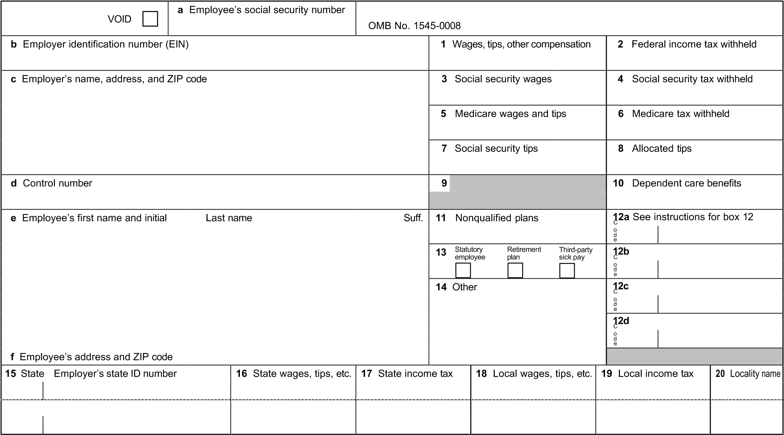

**W-2** **Wage and Tax Statement**  of the Treasury—Internal Revenue Service

**Form For Privacy Act and Paperwork Reduction Copy D—For Employer Act Notice, see separate instructions.**

# Employers, Please Note—

Specific information needed to complete Form W-2 is available in a separate booklet titled the 2024 General Instructions for Forms W-2 and W-3. You can order these instructions and additional forms at *www.irs.gov/OrderForms*.

**Caution:** Do not send the SSA any Forms W-2 and W-3 that you have printed from IRS.gov. The SSA is unable to process these forms. Instead, you can create and submit them online. See

*E-filing*, later.

**Due dates.** By January 31, 2025, furnish Copies B, C, and 2 to each person who was your employee during 2024. Mail or electronically file Copy A of Form(s) W-2 and W-3 with the SSA by January 31, 2025. See the separate instructions. **Need help?** If you have questions about reporting on Form W-2, call the Technical Services Operation (TSO) toll free at 866-455-7438 or 304-263-8700 (not toll free). Deaf or hard-of- hearing customers may call any of our toll-free numbers using their choice of relay service.

**E-filing.** If you file 10 or more information returns, you must file electronically. See Regulations section 301.6011-2 for more information. Even if you aren’t required to file electronically, doing so can save you time and effort. Employers may use the SSA’s W-2 Online service to create, save, print, and electronically submit up to 50 Form(s) W-2 at a time. When you *e-file* with the SSA, no separate Form W-3 filing is required. An electronic Form W-3 will be created for you by the W-2 Online service. For information, visit the SSA’s Employer W-2 Filing Instructions & Information website at *www.SSA.gov/employer*. **Future developments.** For the latest information about developments affecting Form W-2 and its instructions, such as legislation enacted after we release them, go to *www.irs.gov/FormW2*.